Linledin

[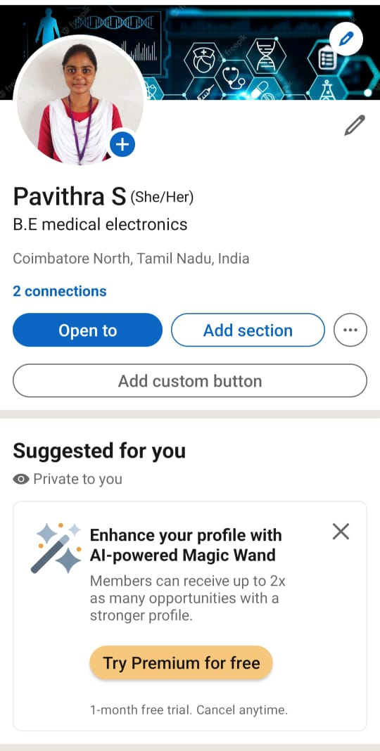](https://www.linkedin.com/in/pavithra-s)https://www.linkedin.com/in/pavithra-s

Facebook Ad

<https://www.facebook.com/profile.php?id=61550514988364&mibextid=2JQ9oc>

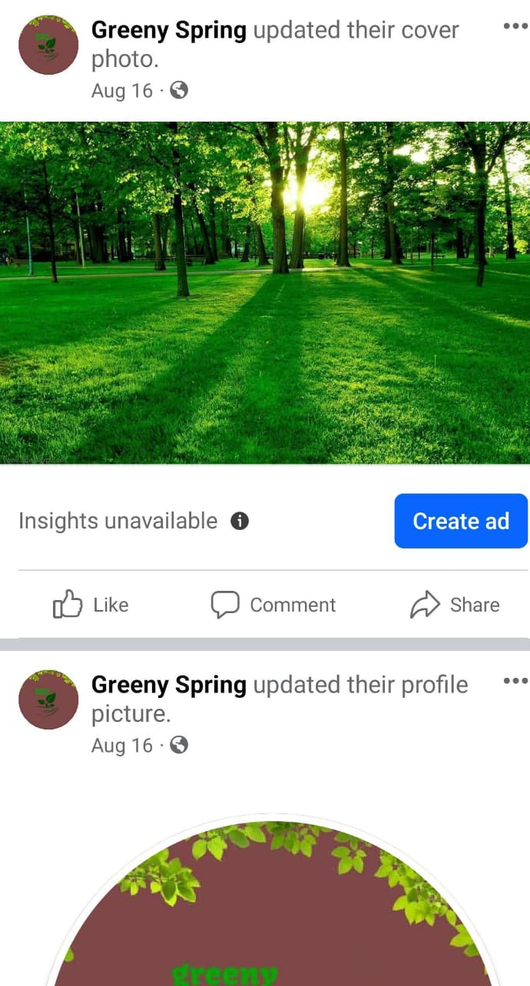

Email newsletter

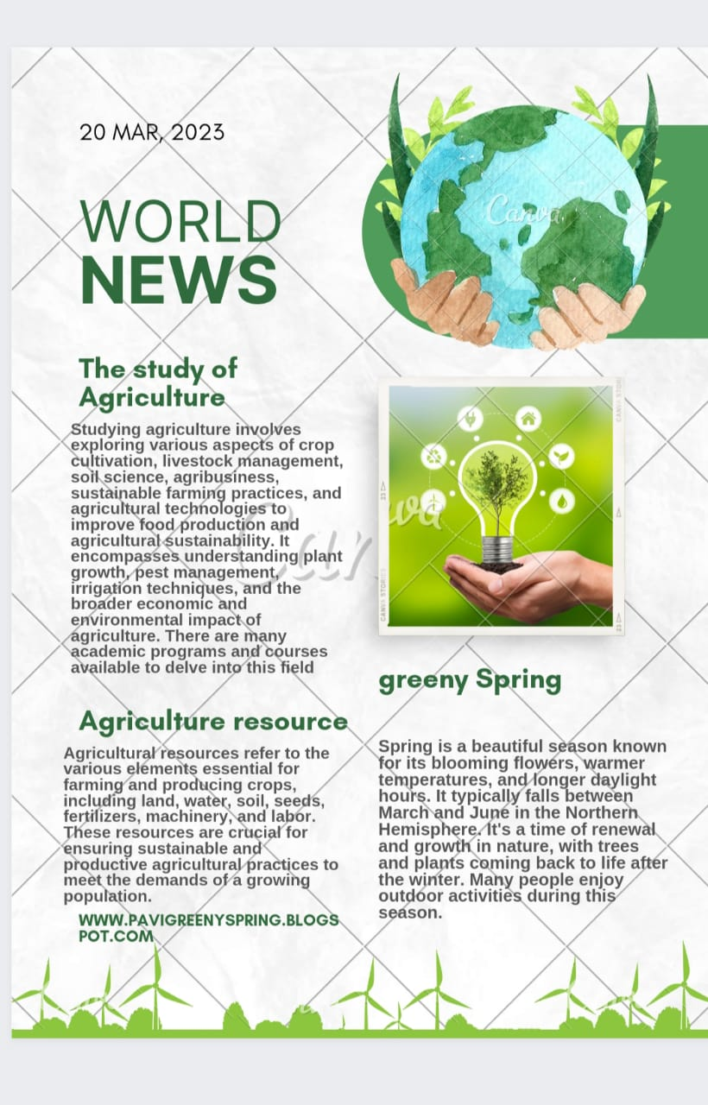https://www.canva.com/design/DAFw8hUXM_Y/v2By4fz-8S4-DdXx8I6RIQ/edit?utm_content=DAFw8hUXM_Y&utm_campaign=designshare&utm_medium=link2&utm_source=sharebutton

Infography

<https://www.canva.com/design/DAFy0nzE1j0/GNK_XZTjIgfkwpNfYNXyVA/edit?utm_content=DAFy0nzE1j0&utm_campaign=designshare&utm_medium=link2&utm_source=sharebutton>

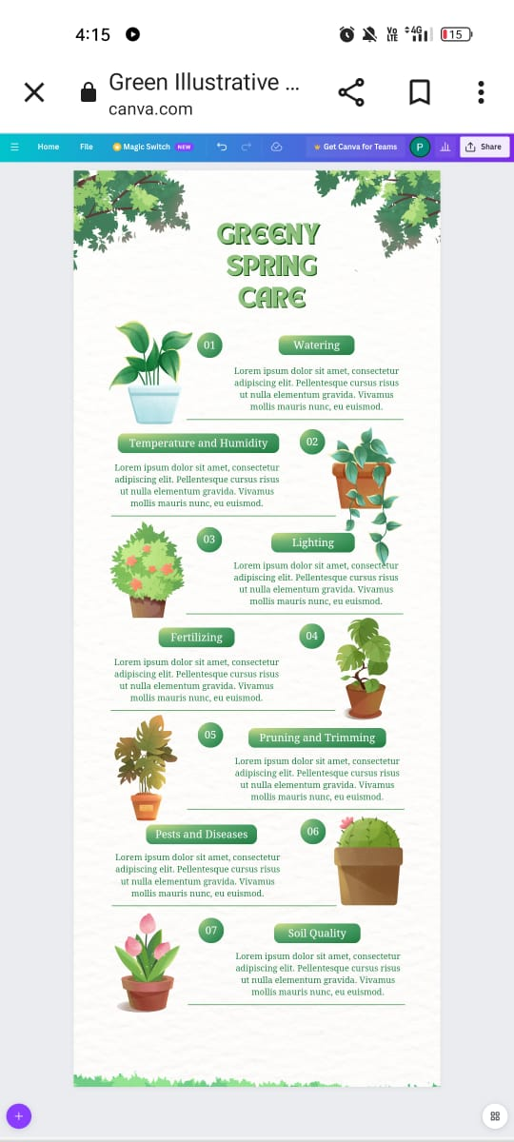

Blog

[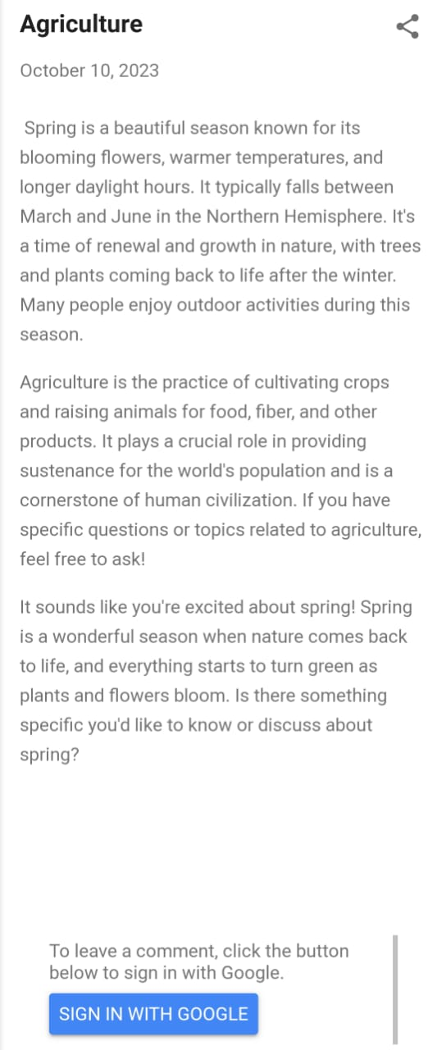](https://pavigreenyspring.blogspot.com/2023/10/agriculture.html?m=1)https://pavigreenyspring.blogspot.com/2023/10/agriculture.html?m=1

Google Analytics

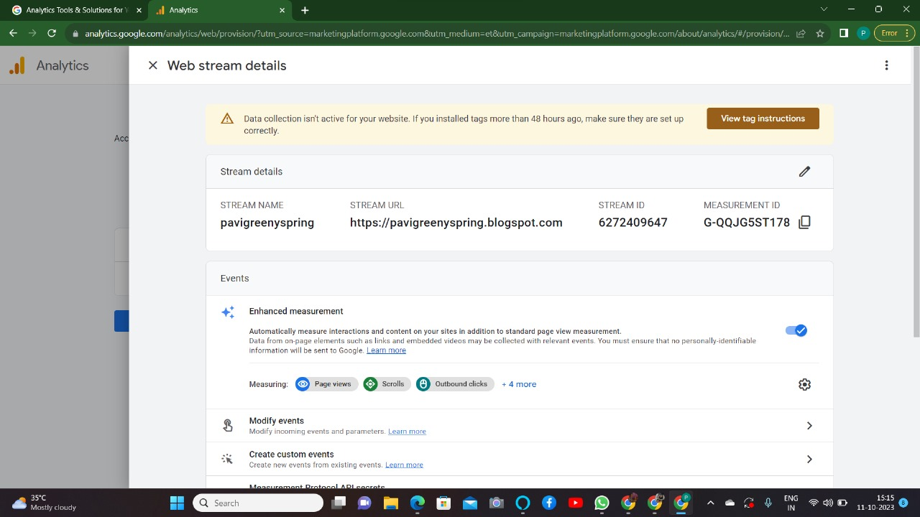http://G-QQJG5ST178/